Workshop 1: Setting interpretative agendas for the
Norman Conquest and transition

Friday 8th December 2017,
Department of Archaeology, University of York
K/159, 10:30 AM-5:00 PM

Aims
The first workshop will focus on brainstorming future directions and setting agendas for the archaeology of the Norman Conquest and the 11th/12th-century and Norman Conquest. While the presentations and discussion will inevitably acknowledge the current state of research, our emphasis will not be just to review it or rehash how we got here. Instead, we want to use the current state of play as a springboard to prioritize possible ways forward, the challenges and opportunities facing the discipline in this period, and the big questions we ideally want to ask and answer. Areas for presentation and discussion will include theoretical approaches, problematizing continuity/change/transition, interdisciplinarity and shared research directions, international perspectives, breaking down current barriers, and new stories of people and things in the 11th and 12th centuries that can be told with archaeology and material culture.

Throughout the workshop, emphasis will be placed on open, positive discussion, where nothing is off the table. The presentations have been designed to stoke debate and shake things up, and to provoke us into thinking in new ways about what archaeology wants and needs to make itself more visible and relevant in the scholarship of this period. What debates can we weigh in on that we have not yet? What narratives can we rewrite or redirect? What can material culture do in helping us understand this period that other sources of evidence cannot? What don’t we know that we want to know? What are OUR agendas?

Schedule

10:30-11:00 Coffee and welcome

11:00-11:15 Introduction

11:15-11:45 Breakout 1: Agenda brainstorming

Session 1: Thinking about the Norman Conquest

11:45-12:00 Mike Fulford: Another conquest: a perspective from Roman Britain

12:00-12:15 David Stocker and Paul Everson: Survival or Revival? Anglo-Saxon kudos in Anglo-Norman England

12:15-12:25 Greger Larson: TBA: ancient DNA

12:25-12:45 Discussion

12:45-1:30 LUNCH

Session 2: Materials and Disciplines

1:30-1:45 Anja Rohde: Small, Difficult and Boring? Coins, Researchers, Curators and the Public

1:45-2:00 Leonie Hicks: Making the landscape visible: reading chronicles with archaeology in mind

2:00-2:15 Katherine Weikert: TBA: interdisciplinary agendas (buildings)

2:15-2:45 Discussion

Session 3: International Perspectives

2:45-3:00 Martin Carver: Normans in Sicily: adventure, multiculturalism and massacre

3:00-3:15 Tadhg O’Keeffe: TBA: Normans and Ireland

3:15-3:45 Discussion

3:45- 4:00 TEA BREAK

4:00-4:30 Breakout 2: Implementing and communicating agendas [interdisciplinary, public, education, etc.], joining up the various arms of archaeology, challenges?

4:30-5:00 Round-up Discussion and Close

Workshop 1 attendees

Aleks McClain, University of York
Naomi Sykes, University of Nottingham
Ben Jervis, Cardiff University
Lizzie Craig-Atkins, University of Sheffield
Tim Pestell, Norwich Castle Museum
Robin Fleming, Boston College
Caroline Palmer, Boydell and Brewer
Mike Fulford, University of Reading
David Stocker, Independent Scholar
Paul Everson, Keele University
Anja Rohde, University of Nottingham
Leonie Hicks, Canterbury Christ Church University
Tadhg O’Keeffe, University College Dublin
Katherine Weikert, University of Winchester
Jonathan Turnock, Durham University
Dawn Hadley, Sheffield University
Sarah Rees-Jones, University of York
Lindy Grant, University of Reading
Rob Liddiard, University of East Anglia
Susan Oosthuizen, Cambridge University
Martin Carver, University of York
Jenny Alexander, University of Warwick
Ross McIntire, University of York
Harriet Evans, University of York

Finding the King’s Manor

King’s Manor is about a 10-15 minute walk from York’s train station, depending on how long your legs are. See the map below.

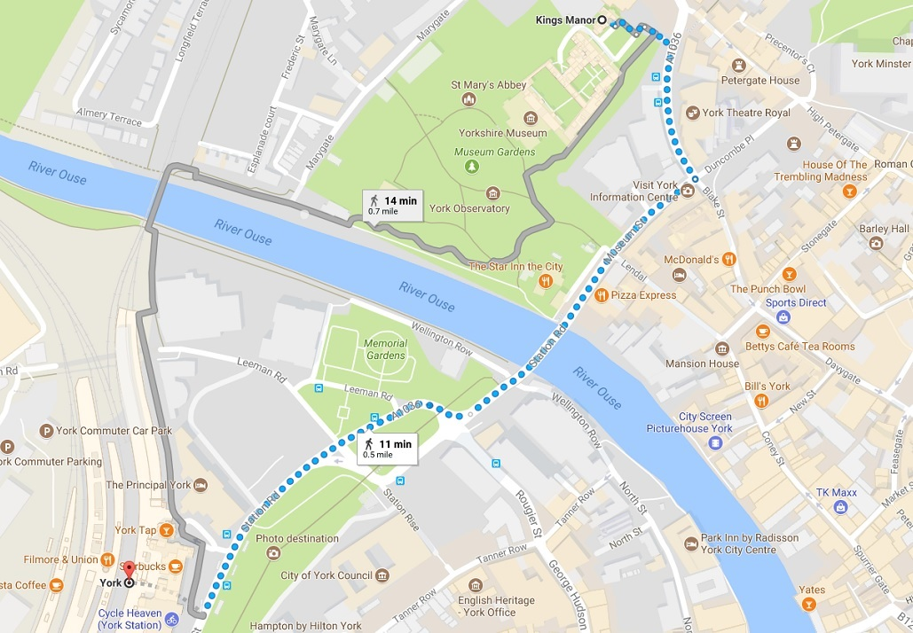

If you are driving, you can park in the KM car park. Drive through the iron gates and follow the driveway around to the right, where you will find the car park. Please let me know your reg number in advance if you are driving, as I need to book it with the security people to keep you from getting a ticket.

Location of K/159

Enter King’s Manor through the porter’s lodge, then go through the first courtyard into the second courtyard. Take the right-hand stone staircase, and at the top, go through the door into the first-floor hallway (not up the wooden stairs to the second floor.) K/159 is immediately on your right when you enter the hallway.

